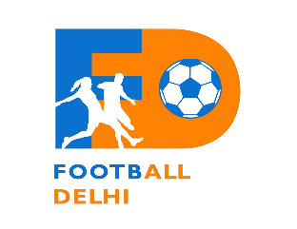
FOOTBALL DELHI - PRESS RELEASE
Hauz Khas, Delhi
15.07.2019
The Football Delhi (Delhi Soccer Association), the Governing Body of Football in Delhi, held its new women’s committee’s formative meeting to discuss and develop the strategy for women’s football in Delhi & NCR.
The committee discussed on various possible ways to work together in evolving a holistic structure to constantly pool and feed talents in the region in to competitions and thereby presenting them an opportunity to be part of strengthening the Delhi state teams competing in the national competitions. The major step intended towards in this direction, is the commencement of an annual women’s football league from this year onwards planned to be conducted to drive participation for the same with a view to grow bigger in the subsequent years. The Football Delhi is seeking suitable partners for conducting the same.
Another major breakthrough in regards to development of women’s football is the signing of a Memorandum of Understanding (MOU) today by The Football Delhi (FD) with Arunodaya Shiksha Prasar Samiti, the NGO operating women’s empowerment and related areas in the NCR. The same partnership had been approved by the Football Delhi executive committee in its last meeting. Both FD and Arunodaya are coming together to promote and develop women’s football in Delhi & NCR through various activities. This MOU will be key in launching women specific Centre of Excellence (COE) for the development of women players.
The Football Delhi Women’s Committee comprises of Mr. Shaji Prabhakaran (Chairman), Ms. Anubhuti Chauhan (Co. Chairman), Ms. Anjum Luthra (Secretary), Ms. Mona Motwani (Dy. Chairman), Ms. Richa Singh (Convener) and Members Ms. Vandita Chauhan, Ms. Shweta Singh, Ms. Abha Jain, Ms. Armaan Dogra, Ms. Sayema Ahmad, Ms. Arprita Majumder and Ms. Jasmeet Walia. Today’s formative meeting was attended by Mr. Shaji, Ms. Anubhuti, Ms. Mona, Ms. Richa, Ms. Shweta, Ms. Arprita and Ms. Jasmeet.

Mr. N K Bhatia
Spokesperson - Football Delhi (Delhi Soccer Association)

